Using decorators

In Yii, we can enclose content into a decorator. The common usage of decorators is layout. When you are rendering a view using the render method of your controller, Yii automatically decorates it with the main layout. Let’s create a simple decorator that will properly format quotes.

Getting ready

Create a new application using the Composer package manager, as described in the official guide at <http://www.yiiframework.com/doc-2.0/guide-start-installation.html>.

How to do it...

1. First, we will create a decorator file, @app/views/decorators/quote. php:

<div class="quote">

<h2>&ldquo;<?= $content?>&rdquo;, <?= $author?></h2>

</div>

2. Now, replace the content of @app/views/site/index. php with the following code:

<?php

use yii\widgets\ContentDecorator;

/\* @var \*/

?> <?php ContentDecorator::begin([

'viewFile' => '@app/views/decorators/quote.php', 'view' => $this,

'params' => ['author' => 'S. Freud']

]

);?>

Time spent with cats is never wasted.

<?php ContentDecorator::end();?>

3. Now, your Home page should look like the following:

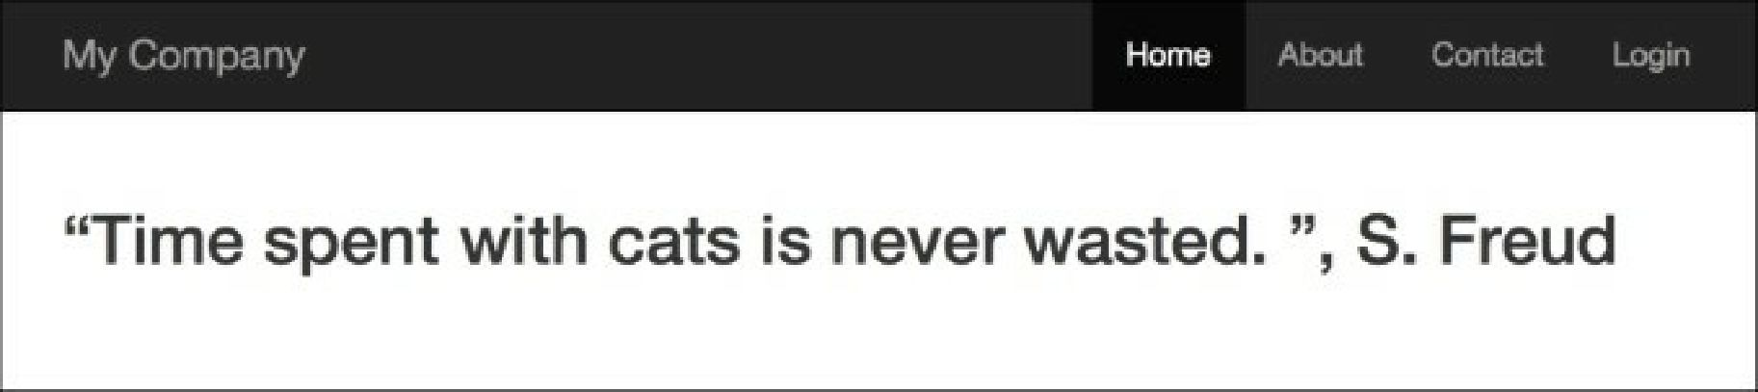

How it works.